greeting.jsp

Handling User Authentication Output



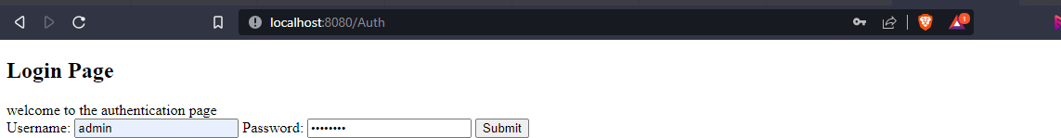authenticate.jsp

success.jsp

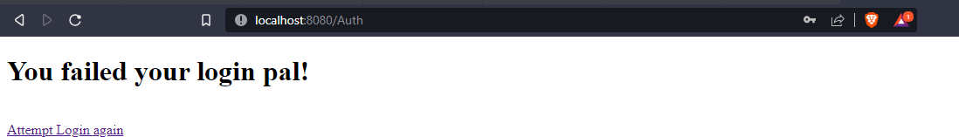failure.jsp

**Junit Test Case**

